BTS7960 43A Motor Drive Module H-Bridge High-Power Driver
Specification:
Item Type: Motor drive module
Feature:
Double high current (43 A) H-bridge driver;
5V is isolated from MCU to effectively protect MCU;
Onboard 5V power indicator;
Voltage indication at the output of the motor driver;
The radiator can be welded;
PIN Definition:
1. RPWM: Turn right to PWM
2. LPWM: Turn left PWM
3. R_EN: Turn right to enable (active high)
4. L_EN: Enable left turn (active high)
5. R_IS: Right turn current warning (may float)
6. L_IS: Left-turn current warning (may float)
7. VCC: (5V)
8. GND
Connection Method:
Method 1:
VCC: 5V from single chip microcomputer (MCU)
GND: GND of the microcontroller (MCU)
L_PWM: PWM or 5V from the microcontroller (MCU) for CCW (CW) turns
R_PWM: PWM or 5V from microcontroller (MCU) for CW (CCW) turns
R_EN and L_EN: 5V from the microcontroller (MCU)
Method 2:
VCC: 5V from single chip microcomputer (MCU)
GND: GND of the microcontroller (MCU)
L_PWM: 5V from the microcontroller (MCU) for CCW (CW) turns
R_PWM: 5V from the microcontroller (MCU) for CW (CCW) turns
R_EN and L_EN: PWM from microcontroller (MCU)
Merely four wires (GND. 5V. PWM1. PWM2) are needed from the MCU to the driver module;
Isolation chip 5 V power supply (can be shared with MCU 5 V);
Can make the motor rotate forward, two PWM input frequencies up to 25kHZ;
Two heat flows through an error output;
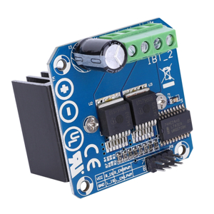
Isolation chip 5V power supply (can be shared with MCU 5V), you can also use the onboard 5V power supply
Power supply voltage 5.5V to 27V;
Package List:
1 x Motor Drive Module
Caption

